Audience->Geo->Location:

We get to see the heatmap of the users as per country/city/continents.

Audience->Mobile->Devices:

We can further drill down to our mobile audiences to see the exact configuration of each devices that are visiting our website.

Bounce Rate:

This is the number of visitors who come to your website and leave without visiting any page beyond the one they landed on. Generally you want the visitors to stay on your website.

Avg Session Duration:

This tells you the average amount of time visitors spent on the website before leaving.

Pages/Session:

This is the number of individual pages a person visits while on the website before leaving.

Behavior Flow

Behavior-> Behavior Flow:

Knowing the visitor numbers are good however we need to know when they move from one page to another, where are they going?

Landing Page: The page user sees after a search or typing the website url.

Exit Pages: The page where the user drops off or close the url/browser tab.

Events:

Behavior->Events -> Top Events

You clicked on the website to move across pages/ play a video/ download link/ your discount code button.

Site Speed:

Behavior -> Site Speed

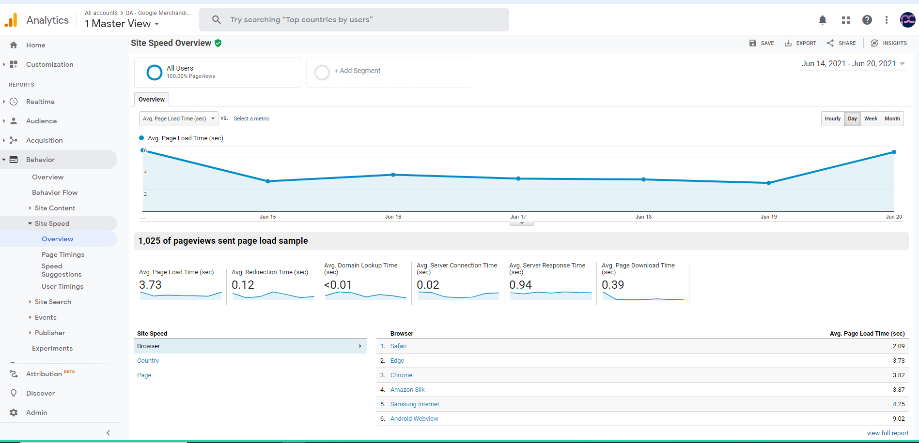

Average page load time: The average amount of time it takes for pages to load.

Average redirection time: the average amount of time spent in redirects before fetching a page.

Average domain lookup time: The average amount of time spent in DNS lookup for a page.

Average server connection time: The average amount of time spent establishing a TCP connection for a page.

Example: Amazon.ca -> DNS->192.168.0.1 -> Connection to server -> website home page -> server response -> website being shown in user browser

Average server response time: The average amount of time your server takes to respond to a user request

Average page download time: The average amount of time it takes to download a page.